Girl Guides of Canada
ANY Council
pathfinder / ranger summer camp
August 17 – 24 2024
Camp Okeekun – Fort MacLeod AB

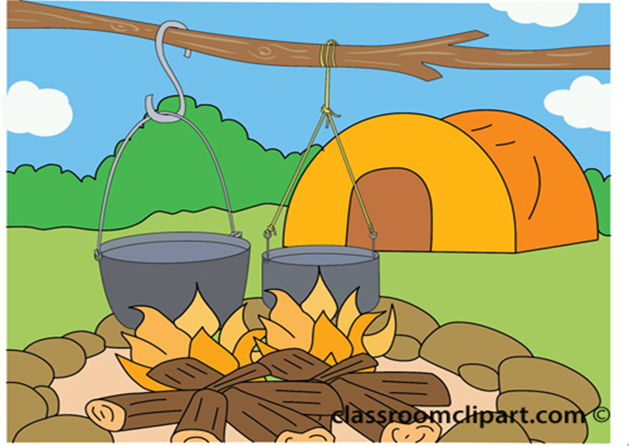

Victoria Woodward any-pathfinderrangercamp@girlguides.ca

Parent
PACKAGE
We would like to welcome you to Pathfinder/Ranger Summer Camp

What is Pathfinder/Ranger Summer Camp?
This event is designed to teach the youth camping/outdoor skills and to have fun! The units will be sleeping in tents and participating in organized activities. The Pathfinders and Ranger will participate in the following activities. The activities are planned and facilitated by the Alberta Provincial Council (ANY) and Third-Party Service Providers.
Activities may include:
- Archery (Third Party Service Provider)
- Axe Throwing (Third Party Service Provider)
- Birds of Prey (Third Party Service Provider)
- Camp style cooking
  - Chopped Cooking Challenge
  - Fire Master Cooking Challenge
- Metis Plant Culture (Third Party Service Provider)
- Hiking
- Mini Golf/Go Karting
- Swimming
- Rafting/canoeing/kayaking (Third Party Service Provider)
- STEM experiments like natural dyes
- And so much more!

Event Date and Times:

August 17 to 24 2024, arrival between 1 – 2 pm at Camp Okeekun, Fort MacLeod, AB (see map)

Go to the Jennifer Peters Site at the camp for check in and unloading.

Transportation to and from the event will be provided by the participants. Directions to the camp to be forwarded after registration is complete.

Please No Pets on the Site!

Pathfinder/Ranger Summer Camp is to be a fun and rewarding experience for all. Being outside and experiencing the outdoors is truly a part of building fond memories. Please ensure that your child has everything that is listed on the kit list so they can enjoy a wonderful camp.

ALL medication sent to camp must be in original container, labeled with written instructions and put in a plastic bag and given to the unit first aider. Please label all items (clothing, dishes, and personal items) that are coming to camp, so we can ensure all belongings go home with the right person.

Due to Alberta’s ever-changing climate, we strongly recommend dressing in layers.

Please find enclosed: Kit List
Tentative Schedule
Map of Camp

There will be further paperwork that will be emailed for signatures, such as Waivers from the TPSP’s for their activities.

If you have any questions, please contact Victoria at any-pathfinderrangercamp@girlguides.ca

# 3 Secondary Highway 811, Fort MacLeod, AB T0L 0Z0
Fire Pit
