2025 Pride Adult t shirt -
comes in sizes s-4x
colors available: Earth Navy or Earth Bone
Size chart
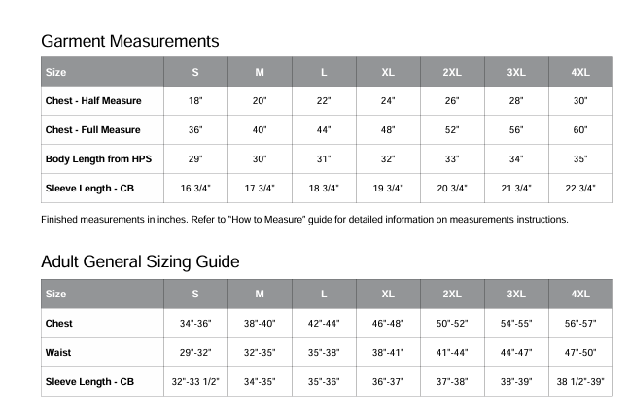

2025 Pride Ladies Cut T shirt
comes in s - 3x
colors are Earth Navy or Earth Bone
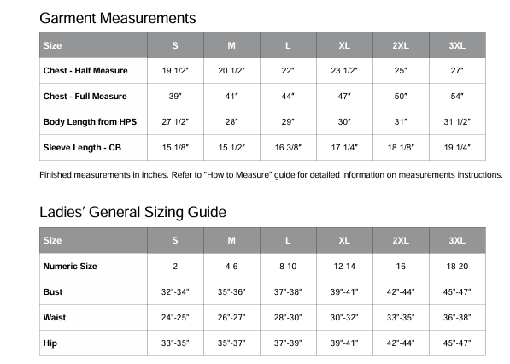

2025 Pride Youth T shirt
Comes in sizes small to xl
available in Earth Navy or Earth Bone
