Embers Camp Academy 2026



PARENT PACKAGE
Responsible Guider
any-calgaryembercampacademy@girlguides.ca
Please reach out to your Unit Guiders FIRST and then use this email address for any additional questions.
March 13-14, please use Jen 403-828-8533 or Elaine 403-828-1575, as we will not be checking emails at this time.

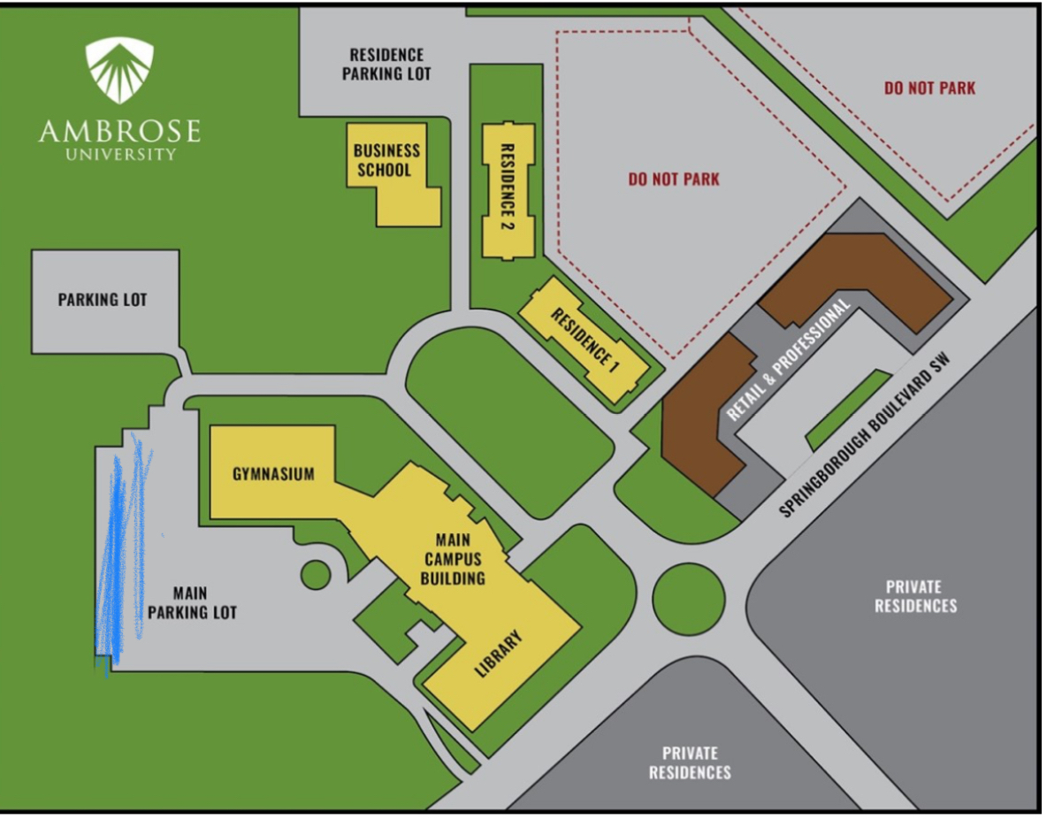
Welcome to Embers Camp Academy 2026!
We are excited that your Ember will be joining us for this year’s adventure!
Event Details:
Ember Camp Academy will take place on Saturday, March 14, 2026 from 8:30am-4:30 pm. Embers will participate in a wide variety of activities to introduce them to camping and the outdoors.
_______________________________________________________
Registration:
Girls will check in with their unit leaders upon arrival at the drop off location below prior to boarding the bus. YOU MUST know your unit number.

All participant information MUST be submitted on time. Or, you might be subject to removal from event.
______________________________________________________________________
Transportation:
All girls and leaders are required to take event-organized bus to and from camp.

Girls and Guiders will arrive and organize themselves together, and UNIT LEADER will check-in with the bus captain prior to boarding the busses. Your leader is to make a sign or visible marker for you to find. LOOK for your UNIT NUMBER

Girls should be dropped off between 8:30am and 8:45am,
the busses will DEPART - at 9am SHARP
bus will return at approximately 4:30pm.

Ambrose University
150 Ambrose Circle SW

See attached map, for drop off and pick up directions.
NO Washroom facility available at bus site

No late arrivals, or you will forfeit your day at camp.
No driving out to camp permitted.

We have provided a map to camp in case of emergency. You must notify your unit leader in order to enter the gates.
Food:
All girls and leaders will need to bring their own nut/peanut-free lunch. Please note there will be NO microwaves or hot water available. Please note that lunch is NOT provided.
All girls will be provided a snack from the event, but may want to bring their own additional snacks in case they get hungry throughout the day.
________________________________________________________________________
Garbage:
Units are responsible for taking all garbage, compost & recycling home with them. We recommend that each girl take home her own garbage with her in her lunch kit.
________________________________________________________________________

Kit List
Ember Camp Academy is designed to be an introduction to camping and the outdoors for Embers and their Guiders, in a fun, day-camp setting. Please ensure that all participants (girls & adults) are prepared for the day and dressed for the weather.
Ember Camp Academy takes place at Camp Jubilee in the Cochrane Valley, and the weather may be slightly colder than in Calgary. Girls will be outside for the day, so layers and being prepared is key.

HEALTH FORM MUST accompany the girl. This must be signed by parent/guardian. Fill in completely.
In the event of an emergency, we will need to know how to help your daughter.
Embers should wear:
- Long sleeved shirt
- Sweat pants or athletic nylon pants - NO DENIM/JEANS or thin leggings
- Warm winter jacket
- Hiking boots or sturdy runners (snow dependent)
- Toque
- socks
Embers should pack in a backpack that they can carry on their own:
- Water Bottle (FULL!)
- Bagged lunch (non-microwavable, nut/peanut-free) & snacks
- Sweater or Hoodie
- Waterproof gloves or mittens
- Extra pair of socks (wool preferred)
- Sunglasses
- Sunscreen
Please make sure that all items are labeled with the participant’s name!!!

