Ember Camp Academy 2026
GUIDER PACKAGE



GUIDER PACKAGE
For any questions contact: any-calgaryembercampacademy@girlguides.ca or call / text 403-828-1575 or 403-828-8533
We will be only accepting calls/text from Friday March 13, onwards.

Welcome to Ember Camp Academy 2026! We are excited that you and your unit are joining us for this year’s adventure!
Event Details:
Ember Camp Academy will take place on Saturday March 14, 2026 from 8:30am-4:30 pm. Embers will participate in a wide variety of activities to introduce them to camping and the outdoors.
Important Dates and registration
- The unit details and attendance list must be completed in full by Guiders by February 15th 2026

- Any units with outstanding or incomplete information, after February 15th 2026, on the unit details and attendance list will forfeit their space

- Unit Guiders must bring a signed SG.2 and H.1 form for each youth

- Unit Guiders must bring a signed H.2 for each adult

- Electronic versions of pictures and/or forms are not permitted

- No refunds will be provided.

- Funds will be taken directly from the unit account.

Bus:
Unit leaders will be responsible for checking in with Bus Captain to ensure their units attendance before boarding the busses. Upon arrival at camp, one leader will come to registration to provide final numbers to the event organizers and collect your registration package. Located at Centennial House South main doors.

Guiders:
Green Ratio must be provided (1:8) and all adults coming should be Guiders or Registered Non-Members (Unit Assistants). A $20 fee will be applied to units that bring additional Guiders over the 1:8 green level ratio requirement.
-Units must provide a unit first aider. There will be a main first aider on site if needed.
-The Ember Academy SG.4 (Emergency Response Plan) will be provided in advance

Transportation:
Parents to drop off (and not stay) between 08:30 AM to 08:45AM.
There is plenty of parking for leaders leaving their vehicle. No washroom facilities available.

AMBROSE UNIVERSITY
150 Ambrose Circle SW

See attached map for directions and parking.

ALL units will bus out to the event. We ask that the units limit Guiders on the bus to 2 per unit. All other Guiders to drive out to site. A First Aider must be on the bus.

There will be directions for parking at camp for those that are driving.
Camp speed limit is 15Km.

Timing: Bus Captains will be on site, check with them BEFORE Boarding.
8:45am: Units to have one Guider at the bussing location to meet their Embers.
9:00am: Embers arrive and check in with their unit
9:15am SHARP: Busses Roll Out to Camp Jubilee
We will not wait for late arrivals. If you are late, you will have to forfeit your day.
You will not have the opportunity to drive to camp.

3:45pm: Bus leaves Camp Jubilee
4:30pm: Busses arrive at bussing pickup location for parent pickup.

To Parents Please know your: Unit Number.
The bus loader will not know where to locate your unit. Have a flag with your unit number or clearly communicate with parents where you will be meeting.

Supervision:
Stations are run by volunteer Guiders.
Patrol Guiders will be actively involved to ensure the success of their own youth participants.

PLAYGROUND is off limits at all times.

Food:
All girls and leaders will need to bring their own nut/peanut-free lunch. Please note there will be NO microwaves available. Please note that lunch is NOT provided.
All girls will be provided a snack from the event, but should bring their own additional snacks in case they get hungry throughout the day.
Garbage:
Units are responsible for taking all their garbage, compost & recycling home with them. We recommend that each girl take her own garbage with her in her lunch kit, but you may find it easier to bring a bag for your unit that you carry around with you and then take with you on the bus at the end of the day.

Kit List
Ember Camp Academy is designed to be an introduction to camping and the outdoors for Embers and their Guiders, in a fun, day-camp setting. Please ensure that all participants (girls & adults) are prepared for the day and dressed for the weather. Remember that Embers are easily encouraged by role models around them, so it is imperative that adults are also dressed for the weather.
Ember Camp Academy takes place at Camp Jubilee in the Cochrane Valley, and the weather may be slightly colder than in Calgary. Girls will be outside the day, so layers and being prepared is key.

If the girl is warm and comfortable, she will have more fun!!
Embers should wear:
- Long sleeved shirt
- Sweat pants or athletic lined nylon pants (NO DENIM/JEANS or thin leggings)
- Warm jacket, snow pants if needed
- Hiking boots or sturdy runners (weather depending)
- Thick socks, knee high preferred
- Hat and mitts
Embers should pack in a backpack that they can carry on their own:
- Water Bottle (FULL!)
- Bagged lunch (non-microwavable, nut/peanut-free) & snacks
- Indoor Shoes
- Sweater or Hoodie
- Waterproof gloves or mittens
- Extra pair of socks
- Sunglasses
- Sunscreen
- **small 250 ml empty and clean soup sized can, NO sharp edges. They must be filed down**
Please make sure that all items are labeled with the participant’s name!!!
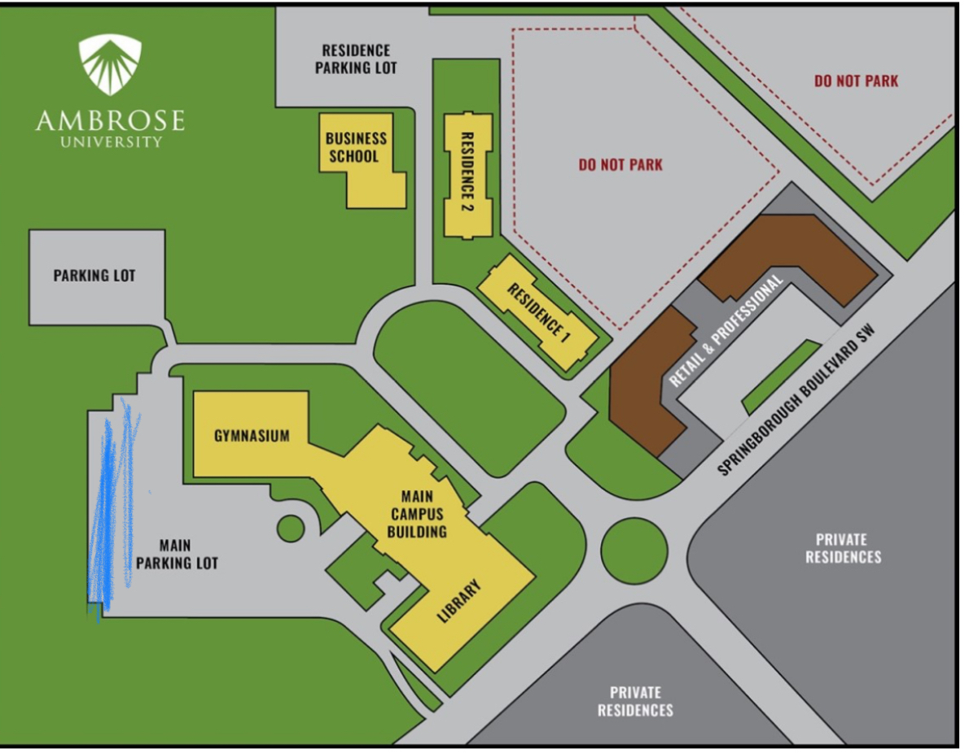

Follow the blue pencil area on map. Bus captains will be on site.
