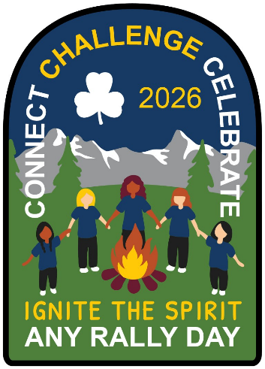

Tamarac Area Rally 2026

Ignite the Spirit-Connect, Challenge & Celebrate

Girl Information Sheet

Event Logistics
Date: Saturday May 2, 2026 from 10:30 a.m. to 3 p.m., registration begins at 10 a.m.
Location: Stony Plain Heritage Park, 5100 41 Avenue Stony Plain Alberta

Transportation and/or pick-up and drop-off arrangements are being coordinated by your unit/district, speak to your unit guiders for more information.

What to Bring*
- A small backpack or daypack
- Water bottle
- Packed bag lunch and snack (no nuts or seafood)
- Coat/rain-wear as appropriate for the weather
- Sunscreen/bug spray
- Sit upon
- Traders & Safety Pins – these are small crafts that are typically attached to your hat or bag and are traded among girls and guiders

What to Wear*
- Wide-brimmed hat
- Uniform t-shirt/tunic (no scarves or sashes)
- Comfortable walking shoes

*Please make sure that everything is labeled!

What to Expect
- Activities will take place both in-doors and out, please plan accordingly but note that the event will go ahead regardless of outdoor conditions (back-up plans are in place)
- Lots of girls and lots of fun!

Activities: Ignite the Spirit-Connect, Challenge & Celebrate
Sparks & Embers | Guides | Pathfinders & Rangers
- Crafts, Games and scavenger hunt | - Craft, Games, Minute to Win it Challenge, Photo Scavenger Hunt | - Detailed craft, Minute to win it Challenge, Photo Scavenger Hunt

