Calgary Area

Guide Camp Skills
May 22 – 24, 2026| Camp Mockingbird

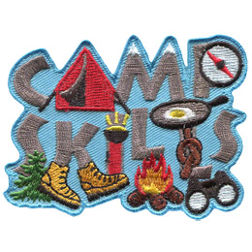

Send any questions to
GUIDER PACKAGE
Any-calgaryguideskills@girlguides.ca

Welcome to Guide Camp Skills!

We are excited that you and your unit are joining us for this year’s adventure!

EVENT DETAILS:
The event will be held from Friday May 22 to Sunday May 24 at Camp Mockingbird. Guides will participate in a wide variety of activities to build camping skills.

BUS:
Parents to drop off (and not stay) at Ambrose University Friday May 22 at 5:45 pm. Pick up will be Sunday, May 24 at 1:15 pm.
There is plenty of parking for leaders leaving their vehicle. No washroom facilities available.

AMBROSE UNIVERSITY - 150 Ambrose Circle SW - See attached map for directions and parking.

ALL units will bus to the event. We ask that the units limit Guiders on the bus to 2 per unit. All other Guiders to drive out to site. Guider driving should have all unit gear. A First Aider must be on the bus. There will be directions for parking at camp for those that are driving.
Unit leaders will be responsible for checking in with Bus Captain to ensure their units attendance before boarding the busses. Upon arrival at camp, one leader will come to registration to provide final numbers to the event organizers and collect your registration package. Located at Lodge.

GUIDERS:
Yellow Ratio must be provided (1:7) and all adults coming should be Guiders or Registered Non-
Members (Unit Assistants). Units must provide a unit First Aider. There will be an Event First Aider on site
if needed.

Attached to the Registration page are the following forms:
- Guider Package
- SG.1 and SG.2 Forms
- Parent Package
- Excel Unit Registration Form
The SG.1, SG.2, and Parent Package are editable. Please add specific information for your unit as you see fit.

Important Ratio Note:
Because this is such a volunteer heavy event, we would like units to provide registered adults to cover Yellow Ratio (1:7) PLUS 1. For example, your unit requires 2 adults to meet a 1:7 ratio, then you need a 3rd registered adult to come with you to help as a volunteer for a station. This can be a Guider or Unit Assistant.

Home contact – Your unit must provide a home contact for your unit. We will give this information to OUR event home contact and in the event of an emergency, the Event Home Contact will phone out to all unit home contacts. Please send them your spreadsheet before the camp.

Cost for the event is $70. This covers:
- Campsite
- Bussing
- Food for Mug Up Friday night, Snacks and Dinner on Saturday.
- Crest
- Supplies for the event

Your unit will be charged based on your Unit Registration Form submitted

This cost does not cover your additional costs and you can also decide how much families cover. Please edit the amount on the SG.1 for your unit.

Deadlines:
April 12, 2026– Unit Registration form with Final numbers sent to any-calgaryguideskills@girlguides.ca

April 19, 2026 - SG.2s must be scanned and emailed to any-calgaryguideskills@girlguides.ca

Parent Meeting
We strongly suggest that you hold a unit Parent Meeting to go over the information and ensure that all Guides are prepared for the event.

What is Guide Camp Skills?
This event is designed to teach the youth camping/outdoor skills and to have fun! The units will be sleeping in tents and participating in organized activities. The Guides will rotate through stations including tent care, outdoor cooking, fire safety, Project Wild, compass and first aid. The activities are planned and facilitated by the Calgary Area Camping committee and other volunteers.

Units will be sharing tent sites with other units.

Program
Please register before setting up your camp, Units will set up camp and then be ready to join us at the evening Mug Up at 9:30 pm outside Brownie Roost.

Guide Camp Skills is to be a fun and rewarding experience for all. Being outside and experiencing the outdoors is truly a part of building fond memories.

Due to Alberta’s ever-changing climate, we strongly recommend dressing in layers.

The Camping Details
Camping | - Units will need to bring all camping gear for the weekend.  - Guiders in a vehicle will bring the gear to and from camp and will be assigned parking.  - Camping will be field camping and will be shared at an established site. Fire pits will be available for units to share with other units but might not be adjacent to their site.  - You need to strain water and use common camping rules – Grey water from food or washing up must be strained and grey water disposed of properly in the LDP.  - Pit toilets are used. No refrigeration for units will be available for an event this size.
Garbage | - Units are responsible for getting all their garbage home from camp.  - We will also be looking for Guider vehicles to take some of the camp garbage at the end of camp.
Sanitation | - Please do all washing up at your own tent site. Bring your own pail & strainer (panty hose) for the LDP. Strained water can be emptied into the site LDP (not down the lats). Put the panty hose into the Unit garbage, which you will take home.  - There are latrines and/or porta-potties on each site. Sanitary supplies (pads & tampons) are to be disposed of in the paper bags provided, NOT down the lats or porta-potties. Please take the used bags to your own garbage.
Water | - Water is available from the pump house.  - Units can bring their own water. Quite often Guides do not like the taste of the water. Plan for 4L per person. This can be done as a group or have Guides bring 4L of water themselves. Water is fine for cooking and dishes.
First Aid | - Event First Aid Station – Lodge  - Each unit must provide a First Aider and First Aid Kit for minor events. The Unit First Aider will fill out an H.4 (First Aid Treatment Record) for any first aid administered.  - Units still need to have their units fill out H.3 (Medication Plan and Administration Record) and they will administer and record Medications.  - Event First Aider will be around for any major incidents.  - All H.3 and H.4 will be handed in to the Event First Aider at the end of the event.
Health Forms | - As the Guides will be with their Guider during the event, the Guider can carry the health forms for the unit. Make sure you have an H.1 for all your Guides. Each Guider may carry their own health form.
Food | - Guides should come to the camp fed.  - Meals provided by the event: Friday Mug Up, Saturday Snacks and Saturday Dinner  - All other meals are provided by the unit. This includes Snacks and Drinks  - All food brought must be Nut Free  - You know what you can prepare in what time frame. Don’t get too intense for this camp but if you can whip up pancakes in no-time, feel free to make pancakes.  Guides can help with cooking, but this won’t be a conventional camp where you have a ton of time for food prep. Decide as a group what is the fastest way to put meals together for your unit.  Pre-cook and heat up where it makes sense.  No refrigeration is provided for units. Units are responsible for providing coolers/ice as required to keep food cold.  The outline below has suggestions for mealtimes and snack breaks. You know your unit best though, so please bring what will sustain your unit!
Friday - Mug up will be done after set up on Friday (supplied by event) and after campfire on Saturday (supplied by unit)
- Hot drink
- Crackers/Cheese/Meat/
- Cup of soup and crackers
- Hot dogs
- Veggies/Hummus
- S’Mores or Chipmunks
- Popcorn

Saturday & Sunday Breakfast
- Hot drink
- Oatmeal (group pot or individual packages!) with non-nut toppings – chocolate, fruit, etc.
- Toasted bagels or English muffins on camp grill with spread (cream cheese or jam)
- Scrambled eggs and bacon – make these into breakfast wraps!
- Egg in a Bag
- Muffins
- Boiled eggs

Saturday Lunch
- Sandwiches – Have an assortment of toppings and spreads and have an assembly line to build their own sandwiches.
- Hot sandwiches (Same as above but double wrap in foil and put in the fire at site (if we are allowed to have fires) – Give yourself some extra time for these. You can do campfire or Camp stove quesadillas or pita pizzas this way too.
- Ramen noodles
- Veggies and dip

Saturday Dinner
- Food for dinner will be provided for your unit to cook at your site. This meal will be based on using a propane camp stove. You will get the recipes in your registration package and details on where to pick up the food.

Snacks
- Have NUT FREE snacks for the between times,
- There will be a morning and afternoon snack provided by the camp.
- Have some extra snacks to have on hand.
- If you want, ask the Guides to bring a small Tupperware sandwich box to carry the snacks.

A more detailed schedule will be sent out closer to the event.

Please ensure each parent is given the complete “Parent Package” including the map to camp. We wish to provide each parent with enough information so that they can comfortably register their daughter while knowing that we take their safety to be of great importance to the success of the event.

Thank You for joining us. We hope you have a wonderful adventure!!
UNIT KIT LIST

This is a list of things that each unit should bring in order for the girls to have the best time possible at Guide Camp Skills. The Guider who drives out to camp should bring all the following items with them. These items are NOT to go on the bus.

- Tents
- Ground Sheets
- Silver Sheets (optional)
- Tent Pegs
- Rope
- Mallet/Hammer

- Scissors
- Stove
- Fuel
- Pots – a couple of very large ones
- Matches
- Tin Foil
- Kitchen Bin
- Cooking Utensils
- 3 Dish Bins for Washing (Guide method)
- Dish Soap and Bleach
- Dish Clothes
- Rope for Hanging Dish Kits
- Tablecloth
- Bucket for LDP and Pantyhose for Straining (X3)
- Water (4L a person)
- Fire starting kit
- Hair Ties

- Extra sleeping bags/Blankets

- First Aid Kit
- Health Forms (original copies) & a Second Set
- H.3, H.4 forms
- Extra Toilet Paper (A couple rolls just in case)
- Hand Sanitizer for your Group
- Duct Tape
- Tent Repair Kit
- Extra Tarps for Sitting or making an Eating Shelter
- Garbage Bags
- Ziploc bags for Snack Kits

- Some cards/extra games
- Some program work for filler activity.

- Empty bins to store smelly stuff and food

Tailor your kitchen kit to what you will be cooking. Things like roasting sticks, tongs, tin foil may be useful if you’re planning on using the fire at all.
You will be camping at a site that may not have a fire pit and benches. We will try to distribute picnic tables around the groups, however there is no guarantee that we will have enough for the size of the event. These are some suggested items:

- A fold up table for your camp stove or a Plank that can be set up as a table with Totes as a makeshift table.
- Camp Chairs – If you can carry them, have Guides bring a camp chair at the meeting before camp. (These won’t be able to be brought by the group gear vehicle)
The camp will provide event toilet paper, but some extras are not a bad idea!

This is a list of suggested minimum requirements. We trust that you know what you need to make your weekend enjoyable.

All items are to be labeled with the Unit/District name!!!

CAMP KIT LIST – PERSONAL KIT LIST
This is a list of things that each camper will need for their adventures at this event. These are general guidelines and a minimum of what the Guides need to have for the weekend. Leaders, please add to this as you see fit for your unit.
All gear should be waterproofed and packed in a large backpack or duffle bag. Large suitcases are not suitable for this kind of camping as they are not waterproof.
You can waterproof bags by packing everything in a garbage bag and putting that into you bag. Guides should aim for one Gear Bag and one Bed Roll (How To Roll a Bedroll) and one Day Pack
Focus on layering clothing to keep warm.

- Sleeping bag
- Extra blanket/sleeping bag liner
- Blue foamy (ensolite pad/thermarest) (NO air mattress)
- Pillow
- Small Stuffed Animal
- Warm 2-piece Pyjamas
- Toque for sleeping
- Mittens for sleeping
- Loose socks for sleeping

- Sturdy hiking boots/shoes or Runners
- 2 pair (4) plastic feet bags

- Socks (minimum 4 pairs)
- Underwear
- Sweat pants or fleece pants (NO JEANS!)
- T-shirt
- Long-sleeved shirt
- Sweater or fleece jacket
- Toque
- Rain Gear (Jacket, Pants)
- Camp hat

- Water bottle 1L (FULL!!!)
- Day Pack
- Plastic mug with lid
- Plastic Dishes (Plate, Bowl, Cutlery)
- Mesh Bag for Dishes

- Personal Kit (toothbrush, toothpaste, Kleenex, brush/comb, hair elastics, sanitary supplies)

- Small personal hand sanitizer
- Personal Medications if needed. Fill out H.3 (Located Here) and give to your Leader before Guides get on the bus.

- Flashlight &Extra Batteries
- Garbage bag for dirty/wet clothes

- Book or Cards

- Sit-upon

No electronics or Individual Food (Discuss with leader) All items are to be labeled with participant’s name!!!

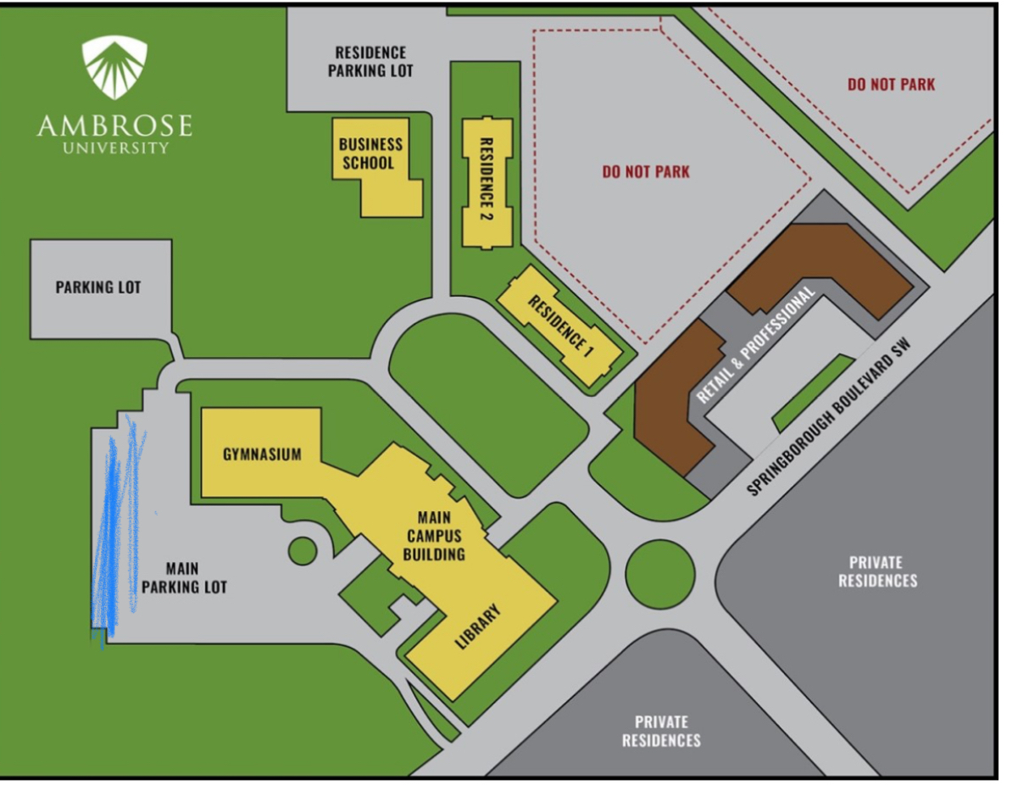

Follow the blue pencil area on map. Bus captains will be on site.

