Calgary Area

Guide Camp Skills
May 22– 24 2026 | Camp Jubilee

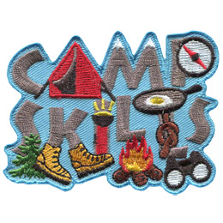

PARENT/ GUARDIAN PACKAGE

Welcome to Guide Camp Skills!

We are pleased that your Guide is joining us on this adventure. This package is designed to answer your questions about the event at Camp Jubilee.

What is Guide Camp Skills?

This event is designed to teach the youth camping/outdoor skills and to have fun! The units will be sleeping in tents and participating in organized activities. The Guides will rotate through stations including tent care, outdoor cooking, fire safety, games, hiking, compass and first aid. The activities are planned and facilitated by the Calgary Area Camping committee and other volunteers.

Units will be sharing tent sites with other units.

Event Date and Times: The event will be from Friday May 22 to Sunday May 24, 2026.

BUS: Parents to drop off (and not stay) at Ambrose University Friday May 22 at 5:45 pm. Pick up will be Sunday, May 24 at 1:15 pm.

AMBROSE UNIVERSITY - 150 Ambrose Circle SW - See attached map for directions

Guide Camp Skills is to be a fun and rewarding experience for all. Being outside and experiencing the outdoors is truly a part of building fond memories.

Due to Alberta’s ever-changing climate, we strongly recommend dressing in layers.

CAMP KIT LIST – PERSONAL KIT LIST
This is a list of things that each camper will need for their adventures at this event. These are general guidelines and a minimum of what the Guides need to have for the weekend. Leaders, please add to this as you see fit for your unit.
All gear should be waterproofed and packed in a large backpack or duffle bag. Large suitcases are not suitable for this kind of camping as they are not waterproof.
You can waterproof bags by packing everything in a garbage bag and putting that into you bag. Guides should aim for one Gear Bag and one Bed Roll (How To Roll a Bedroll) and one Day Pack
Focus on layering clothing to keep warm.

- Sleeping bag
- Extra blanket/sleeping bag liner
- Blue foamy (ensolite pad/thermarest) (NO air mattress)
- Pillow
- Small Stuffed Animal
- Warm 2-piece Pyjamas
- Toque for sleeping
- Mittens for sleeping
- Loose socks for sleeping

- Sturdy hiking boots/shoes or Runners
- 2 pair (4) plastic feet bags

- Socks (minimum 4 pairs)
- Underwear
- Sweat pants or fleece pants (NO JEANS!)
- T-shirt
- Long-sleeved shirt
- Sweater or fleece jacket
- Toque
- Rain Gear (Jacket, Pants)
- Camp hat

- Water bottle 1L (FULL!!!)
- Day Pack
- Plastic mug with lid
- Plastic Dishes (Plate, Bowl, Cutlery)
- Mesh Bag for Dishes

- Personal Kit (toothbrush, toothpaste, Kleenex, brush/comb, hair elastics, sanitary supplies)

- Small personal hand sanitizer
- Personal Medications if needed. Fill out H.3 (Located Here) and give to your Leader before Guides get on the bus.

- Flashlight &Extra Batteries
- Garbage bag for dirty/wet clothes

- Book or Cards

- Sit-upon

No electronics or Individual Food (Discuss with leader) All items are to be labeled with participant’s name!!!

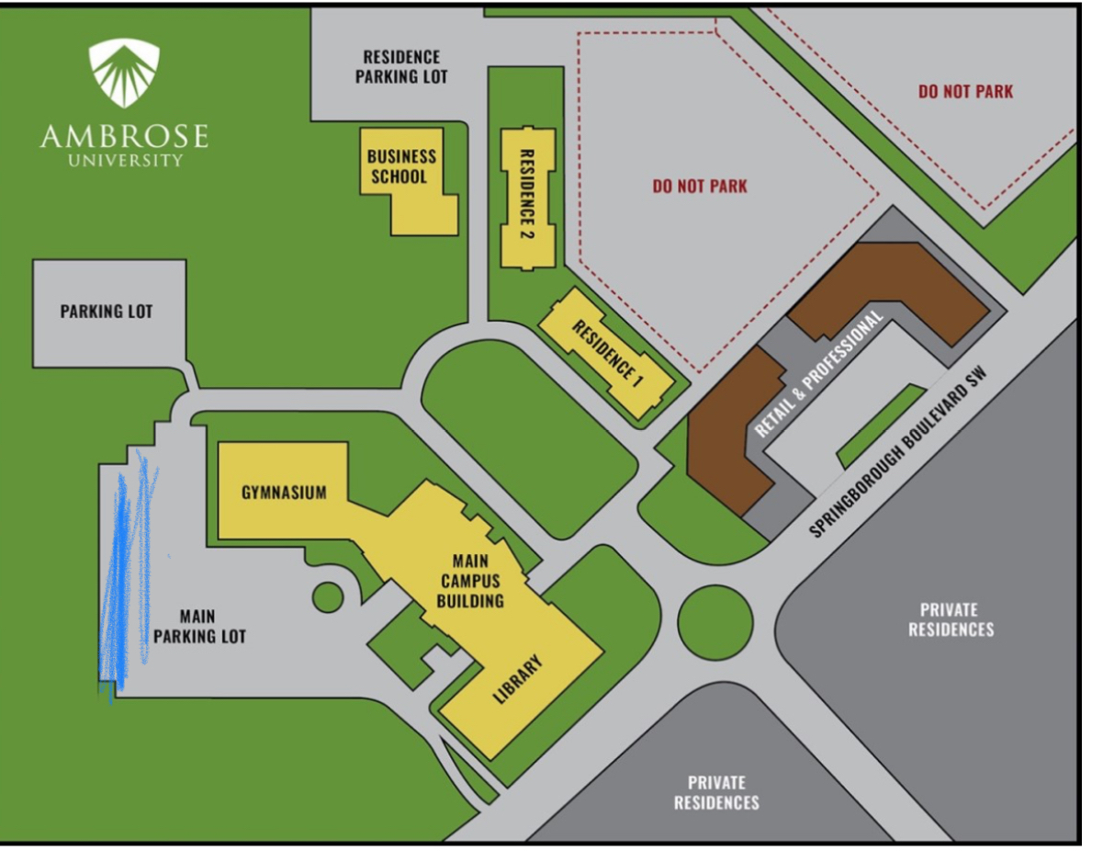

Follow the blue pencil area on map. Bus captains will be on site.

