

Welcome to Ignite Conference 2026: The S'more We Learn Together!
We're thrilled to have you join us for a weekend of connection, inspiration, and shared learning. Just like the perfect campfire brings people together, this conference is an opportunity to spark new ideas, strengthen friendships, and build skills that will help us grow as leaders and Guiders.
Thank you for bringing your experience, enthusiasm, and unique perspective. Together, we'll learn, laugh, and create memories that will last long after the campfire fades.
Welcome to Ignite 2026, where the s'more we learn together, the brighter we shine!

Conference Details
Date: Friday October 16 – Saturday, October 17th, 2026
Location: Saint John High School, 170-200 Prince William St., Saint John NB
Hotel: Delta Hotel, 29 King St., Saint John NB
Registration Fee: $34.79 plus HST ($40.00)

Getting to the Conference: Saint John High is a short 6-minute walk from the Delta Hotel accommodation. For those with mobility issues or those not staying at the hotel, you can find parking all along Prince William Street, Duke Street and Canterbury Streets. There is no charge for metered on street parking after 6:00pm on Friday and all weekend.

New This Year
Our Friday evening social will be held at the conference venue. Saturday will be a full day of learning and connections ending at 4pm so attendees can travel home during the daylight hours.
Voting Provincial Council members will be participating in a Saturday evening learning session and Sunday morning Council meeting.

Meals and Mileage Information
Meals
Attendees are responsible for their supper on Friday evening and Saturday morning breakfast. You will be provided with 2 snacks and lunch on Saturday as part of your registration fee.

Mileage
Guiders are eligible for mileage for travel exceeding 100kms round trip for this event. Any costs associated with travel (including road tolls, bridge fees etc) is included in the mileage rate.
Type of Travel | Rate
Individuals who travel alone | 0.40/km
Carpooling | 0.55/km

Carpooling mileage will be paid to the driver only and the driver will be responsible for providing the names of all those who travel with them on their mileage form.
Direct deposit is the preferred payment option. Cheques can be requested if direct deposit is not an option. Cheques under $250 are issued three times per year (December, April and August).

Hotel Accommodations
We have secured a block of hotel rooms for travelling conference attendees at the Delta Hotel, 59 King St., Saint John. Rooms are double occupancy. If you require a single room, the cost is $99.
Attendees can book their rooms here: Reservation-Link
When you book your room, please make a note of who you will be sharing with on the reservation. We kindly ask that you do not book multiple rooms to avoid confusion.
Accommodation for Guiders will be provided for one night, Friday, October 16th with check out the morning of Saturday, October 17th. Provincial council members and invited guests will be provided accommodations for two nights October 16 – October 18th.

Conference Schedule at a Glance
Friday
Time | Event | Location
6:30pm | Early Registration | Saint John High
7:00pm – 9:00pm | Social Time | Saint John High
Saturday
Time | Event | Location
7:30am | Registration Opens | Saint John High
9:00am | Welcome | Saint John High
9:30am – 10:30am | Session One | Saint John High
10:45am – 11:45am | Session Two | Saint John High
12:00pm | Lunch | Saint John High
1:00pm – 2:00pm | Session Three | Saint John High
2:15pm -3:15pm | Session Four | Saint John High
3:30pm | Closing | Saint John High
6:00pm | Provincial Council Training | TBD
Sunday
Time | Event | Location
9:00am | Provincial Council Meeting | Delta Hotel

Service Project
We will be collecting easy to prepare food items for weekend food backpacks for students at Saint John High School. Items should be microwaveable or ready to eat some suggestions can be found here: Food Suggestions
First Aider Information:
Maddy Cook-Lockhart will be our event first aider, if you need to seek assistance during the conference, please find an organizing member and we will connect you with her.

Emergency Response Plan:
In the event of an emergency all attendees are asked to muster at the Main Gate entrance to the Area 506 Container Village for headcount and instructions. 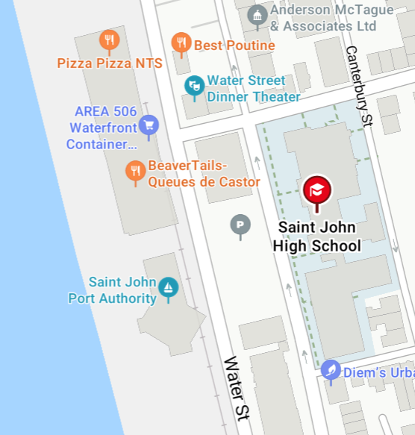

Session Information

