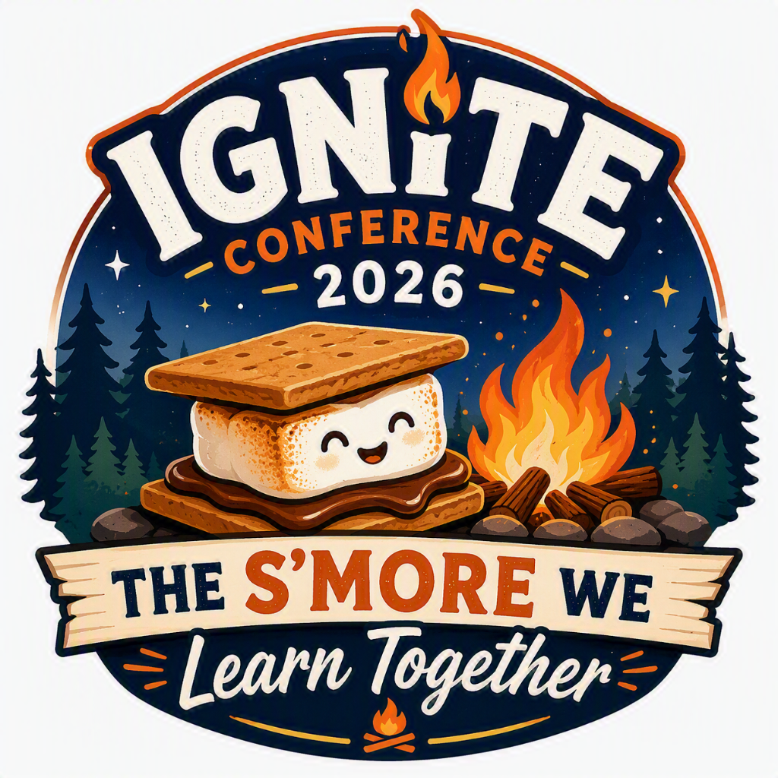

Welcome to Ignite Conference 2026: The S'more We Learn Together!
We're thrilled to have you join us for a weekend of connection, inspiration, and shared learning. Just like the perfect campfire brings people together, this conference is an opportunity to spark new ideas, strengthen friendships, and build skills that will help us grow as leaders and Guiders.
Thank you for bringing your experience, enthusiasm, and unique perspective. Together, we'll learn, laugh, and create memories that will last long after the campfire fades.
Welcome to Ignite 2026, where the s'more we learn together, the brighter we shine!

Conference Details
Date: Friday October 16 – Saturday, October 17th, 2026
Location: Saint John High School, 170-200 Prince William St., Saint John NB
Hotel: Delta Hotel, 29 King St., Saint John NB
Registration Fee: $34.79 plus HST ($40.00)

Getting to the Conference: Saint John High is a short 6-minute walk from the Delta Hotel accommodation. For those with mobility issues or those not staying at the hotel, you can find parking all along Prince William Street, Duke Street and Canterbury Streets. There is no charge for metered on street parking after 6:00pm on Friday and all weekend.

New This Year
Our Friday evening social will be held at the conference venue. Saturday will be a full day of learning and connections ending at 4pm so attendees can travel home during the daylight hours.
Voting Provincial Council members will be participating in a Saturday evening learning session and Sunday morning Council meeting.

Meals and Mileage Information
Meals
Attendees are responsible for their supper on Friday evening and Saturday morning breakfast. You will be provided with 2 snacks and lunch on Saturday as part of your registration fee.

Mileage
Guiders are eligible for mileage for travel exceeding 100kms round trip for this event. Any costs associated with travel (including road tolls, bridge fees etc) is included in the mileage rate.
Type of Travel | Rate
Individuals who travel alone | 0.40/km
Carpooling | 0.55/km

Carpooling mileage will be paid to the driver only and the driver will be responsible for providing the names of all those who travel with them on their mileage form.
Direct deposit is the preferred payment option. Cheques can be requested if direct deposit is not an option. Cheques under $250 are issued three times per year (December, April and August).

Hotel Accommodations
We have secured a block of hotel rooms for travelling conference attendees at the Delta Hotel, 59 King St., Saint John. Rooms are double occupancy. If you require a single room, the cost is $99.
Attendees can book their rooms here: Reservation-Link
When you book your room, please make a note of who you will be sharing with on the reservation. We kindly ask that you do not book multiple rooms to avoid confusion.
Accommodation for Guiders will be provided for one night, Friday, October 16th with check out the morning of Saturday, October 17th. Provincial council members and invited guests will be provided accommodations for two nights October 16 – October 18th.

Conference Schedule at a Glance
Friday
Time | Event | Location
6:30pm | Early Registration | Saint John High
7:00pm – 9:00pm | Social Time | Saint John High
Saturday
Time | Event | Location
7:30am | Registration Opens | Saint John High
9:00am | Welcome | Saint John High
9:30am – 10:30am | Session One | Saint John High
10:45am – 11:45am | Session Two | Saint John High
12:00pm | Lunch | Saint John High
1:00pm – 2:00pm | Session Three | Saint John High
2:15pm -3:15pm | Session Four | Saint John High
3:30pm | Closing | Saint John High
6:00pm | Provincial Council Training | TBD
Sunday
Time | Event | Location
9:00am | Provincial Council Meeting | Delta Hotel

Service Project
We will be collecting easy to prepare food items for weekend food backpacks for students at Saint John High School. Items should be microwaveable or ready to eat some suggestions can be found here: Food Suggestions
First Aider Information:
Maddy Cook-Lockhart will be our event first aider, if you need to seek assistance during the conference, please find an organizing member and we will connect you with her.

Emergency Response Plan:
In the event of an emergency all attendees are asked to muster at the Main Gate entrance to the Area 506 Container Village for headcount and instructions. 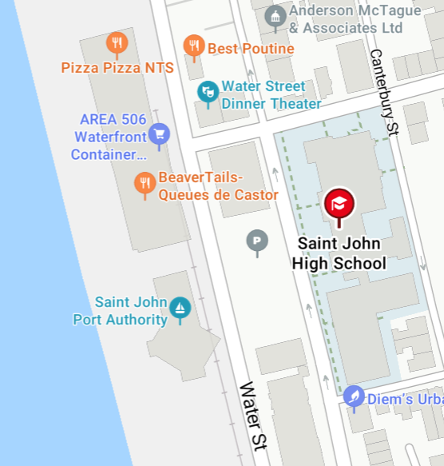

Session Information
Session One 9:30 – 10:30am
Planning Day Outings and Sleepovers
Session Description: prepare to venture beyond your regular unit meetings by learning how to plan a day outing or a sleepover where you plan the program activities yourself.

Make It - Use It - Love It
Session Description: a fun training where you'll get ideas to help kids create practical projects they’ll actually keep—gifts, gear, and goodies that don't end up getting left behind at the meeting space.

Escape Room Design Workshop
Session Description: Participants experience a mini escape room, learn the basic structure of escape room design, and work in teams to create a Guiding-themed escape room that could be run at a unit meeting, camp, district event, or conference

New Guider Must Haves
Session Description : practical and welcoming training session for new Unit Guiders and Welcome Guiders alike. Explore the basics of Guiding, key resources, meeting planning, safety, traditions, digital tools, and ways to support new volunteers as they begin their Guiding journey. Perfect for anyone looking to build confidence, connection, and leadership skills within Girl Guides.

Rookie Camp Crew
Session Description: (Basic Camp Skills for new Campers) - Come learn the very basic of going to camp for the first time.

The Smore We Plan Together
Session Description: Engage your girls in planning an exciting year. Learn tips and tricks for fitting it all in.

No Burnt Marshmallow: Navigating Conflict Without Getting Toasted
Session Description Conflict isn't a sign something is wrong. It's a sign that people care.In this practical and entertaining session, participants learn how to handle disagreements while protecting relationships. The focus is not on avoiding conflict, it's on having better conversations.
How the Cookie Crumbles
Session Description: Learn everything you need to know about our cookie program, why it is so important to the organization and how to maximize your unit's cookie selling!

Session 2 Time: 10:45-11:45
Running Day Outings and Sleepovers
Session Descritpion: Explore the skills you need on the day of your special experience, including managing the group in a new setting, being flexible to changing needs, and sharing leadership during a longer experience.

Financial Jeopardy
Session Description: Join us in this jeopardy style activity and hit on GGC financial hot topics and trouble spots to keep yourself out of 'financial jeopardy'

For History to Her-Story
Session Description: Making Guiding history fun for Kids- How to make Guiding history fun for all ages

Science Lab
Session Description: This interactive workshop gives adult Girl Guide leaders the opportunity to explore fun, engaging science experiments using inexpensive, everyday household materials. Participants will take part in hands-on activities, learn the science behind each experiment, and discover practical ways to adapt them for different age groups. Leaders will leave with easy-to-use ideas that inspire curiosity, encourage problem-solving, and make STEM programming accessible without stretching their unit budget.

Wiggles and Giggles
Session Description: The girls are running around like chickens with their heads cut off and so are you? Let's wear them out!

Borrow This Meeting
Session Description: A ready to use program swap for busy guiders

Survivor Unit Edition
Session Description: By the end of the session, participants will:
• Experience a mini Survivor event
• Participate in physical, creative, and teamwork challenges
• Learn how to adapt activities for Sparks through Rangers
• Leave with a ready-to-run Survivor event package

Talking to Kids about Healthy Relationships

Session 3: Time: 1:00-2:00

Managing Food for Day Outings and Sleepovers
Session Description: Explore how to plan and prepare safe, inclusive, and satisfying meals for your experience. Learn how to create thoughtful menus, manage dietary needs, estimate quantities, and practice safe food handling and clean-up.

Wacky Tune Time
Session Description: Share silly songs for when you need a giggle.

Unravelling the Girls First Platform
Session Description: How to explore the Girls Platform and where to record activities

Ceremony Glow Up
Session Description: Come ready to learn how to Glow up your next youth ceremony they will always remember. There are plenty of ceremonies to be had to celebrate our youth members. This session will discuss how to plan with the youth and how to take their ideas and make some ceremonies they will never forget.

Shenangians Wide Games
Session Description: This energetic, hands-on workshop introduces adult Girl Guide leaders to a variety of wide games and quick 5-minute activities that get girls moving, working together, and having fun. Participants will learn games that encourage teamwork, communication, and physical activity while being easily adaptable for different age groups, abilities, and accessibility needs. Whether you have a large outdoor field or a small indoor meeting space, leaders will leave with a collection of flexible, low-prep games they can confidently use at meetings, camps, and events.

Youth Forum Led Session Raising Future leaders
Session Description: this session will show how girl-led meetings help girls develop confidence, leadership skills, and a stronger sense of belonging. Participants will explore how creating meetings for girls, by girls empowers youth, encourages personal growth, and makes Guiding a more engaging and enjoyable experience. Participants will leave with practical ideas for fostering leadership and increasing girl engagement in their units.

Last Minute Meeting Toolkit
Session Description: This fast-paced workshop helps Guiders prepare for the unexpected. Participants work in teams to solve real-life Guiding "meeting disasters" and build a collection of emergency meeting plans, games, and activities that can be pulled out at a moment's notice. You'll leave with practical resources you can use the very next time a meeting goes off the rails.

All About Welcome Guiders and the Unit Guider Orientation Program

