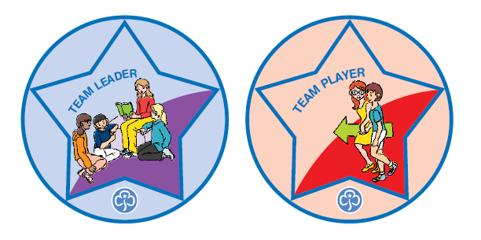
Patrol Leader Camp
October 24th, 2026
11 am until 7:30 pm

Who: Guides who are to be Patrol Leaders
Cost: $12 per girl Where: Camp Arbuckle
Why? So girls are able to develop leadership skills and tools to lead their patrols in their Guide groups while having fun!
Registrations are to be 4 to 6 Girls and 1 Guider. Please note that accommodations can be made for fewer girls and/or no Guiders. Just email Barb at guiderbarbw@gmail.com to check for ratios and space.
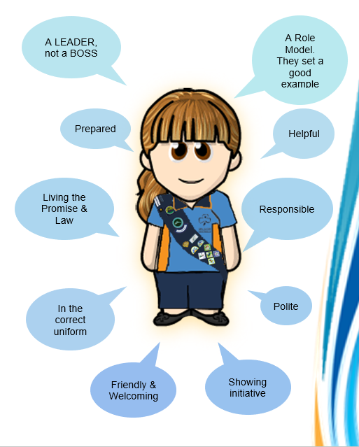
Guiders will be needed to help with
stations and duties.

Space is limited so register early
as some patrols have been turned away
in previous years.

