Unit Kit List

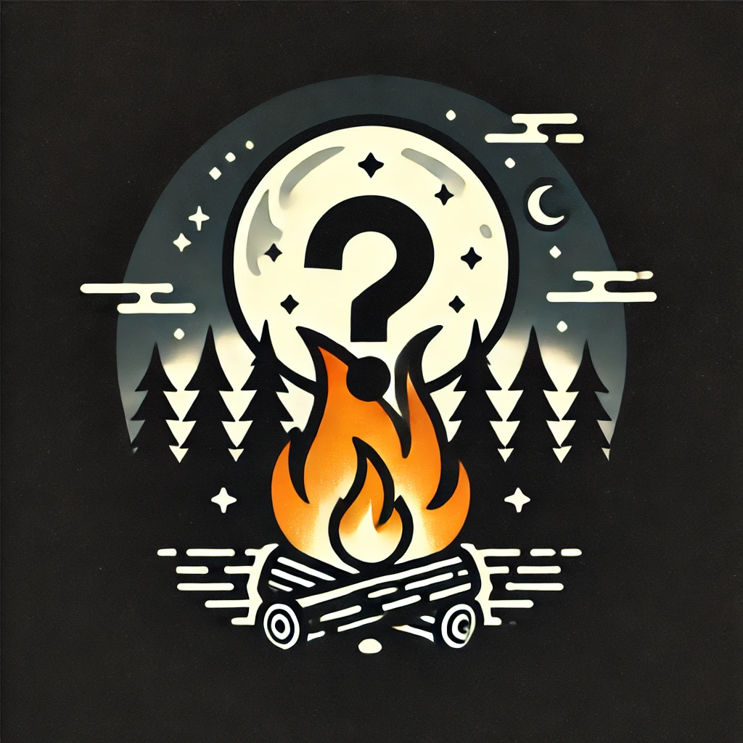

| Camp Cooking   * Stove * Windscreen (could be part of stove) * Fuel * Fire suppression * Lighter/matches * 2X pan, or 1 pan and griddle top * 1-2 Pots * Portable table (if available) | Camp kitchen   * Cheese grater * Cutting board * Knife(s) * Large lifting spoon * Large Bowl * scraper/lifter * Water container * Juice container * Leftover containers * Cooler |
| --- | --- |
| Group Camping   * Tents * Tarp/rope or cooking shelter * Candle/lantern | Safety   * SG forms * Unit First AId Kit * Repair Kit * Cell phone with power bank |
| Dishwashing   * 3 Bins * Soap, * Bleach * Rope for mesh bag line * Garbage Bag * Compost Bag | Other (if available)   * Campfire Popcorn Maker * Tin foil * Buddy Burner kit (about 3 per group) * Campfire cooking sticks * Secondary items to accommodate unit allergies. |
| [Ice Cream](https://experience.girlguides.ca/node/235051)   * 2 metal tins with lids, 1 larger than other OR * Multiple zip lock bags, in 2 sizes. | Food   * Oil * Salt and pepper * Favourite drink mix |