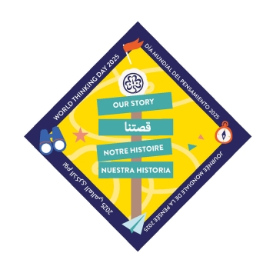CUPCAKES AND CANDLES 202%

Dear Guiders,

“Cupcakes and Candles” is happening at Camp Arbuckle on Feb 21st through 23rd, 2025. The theme will be “Our Story”; the Girl Guide and Girl Scout experience is a lifelong adventure of connecting with the world around us and the people we meet. This World Thinking Day (WTD), we invite you to explore and celebrate, reflecting on the symbolism and values of WAGGGS and exploring what it has meant to be a Girl Guide and Girl Scout over the years. This is an indoor international event for

the girls. The girls are divided into groups and circulate through stations that are organized by the patrols as well as some developed by the Core Staff. They will be put into

mixed groups for activities, giving them an opportunity to make new friends.

* All 2nd& 3rd year Guides and all Pathfinders are invited to attend.
* We encourage patrols of 8 girls with 1 Guider
* The cost will be $45.00 per girl.
* Only one guider per patrol.
* If your patrol is less than 6 girls we will be charging an extra $20.00 for the guider.
* Please note that accommodations will be made for more or less girls and/or no Guiders-- please contact Barb Wilson at [guiderbarbw@gmail.com](mailto:guiderbarbw@gmail.com)

Patrols will arrive ***together*** between 6:30 pm and 6:45 pm on February 21st, 2025.

Each patrol is to bring a station which represents a country of their choice. Be sure that the country you choose is a WAGGGS member (no World Centre countries, please!). You are to submit 3 choices for the country so duplication of countries can be avoided. Country choice given is first come, first pick.

Your station is to be staffed by the patrol guider so that the girls can go to all the stations. All patrol guiders will be expected to help with other stations when not running their patrol’s station.

Station to contain:

* Information to share about your country, should include something about Guiding in that country
* Something for the girls to do as an activity (must be culturally sensitive)
* Traders representing your country (optional)
* Station to be planned for 10 to 20 minutes in duration. Please plan for flexibility.

Once again we will have a Guiding in the World presentation on Saturday evening. To clarify—the girls have a chance to give a presentation on their country of choice—this could be a skit or fun facts, or pretty much anything the girls come up with. Presentation to be no longer than 5 to 7 minutes per patrol

GGC’s Stance: GGC encourages all members to plan and engage in programming and activities that respect cultures. We disrespect cultures when activities use someone else’s culture without thinking about, and acknowledging how our actions affect the people whose culture we are engaging. When we do that we are engaging in cultural appropriation. Cultural appropriation is when we make use of a symbol, activity, or aspect

of a culture that is reserved solely for those who are part of that culture.

The girls are encouraged to make displays for their country and we ask that the patrol try to demonstrate a way in which they have tried to connect with their country of choice.

**We will accept patrols on a first come, first served basis**. A list of final participants will be chosen no later than January 30th, 2025. You will be notified of your acceptance to the event.

This is a terrific weekend for the girls and Guiders!! So come out and join the fun!!