Personal Kit List

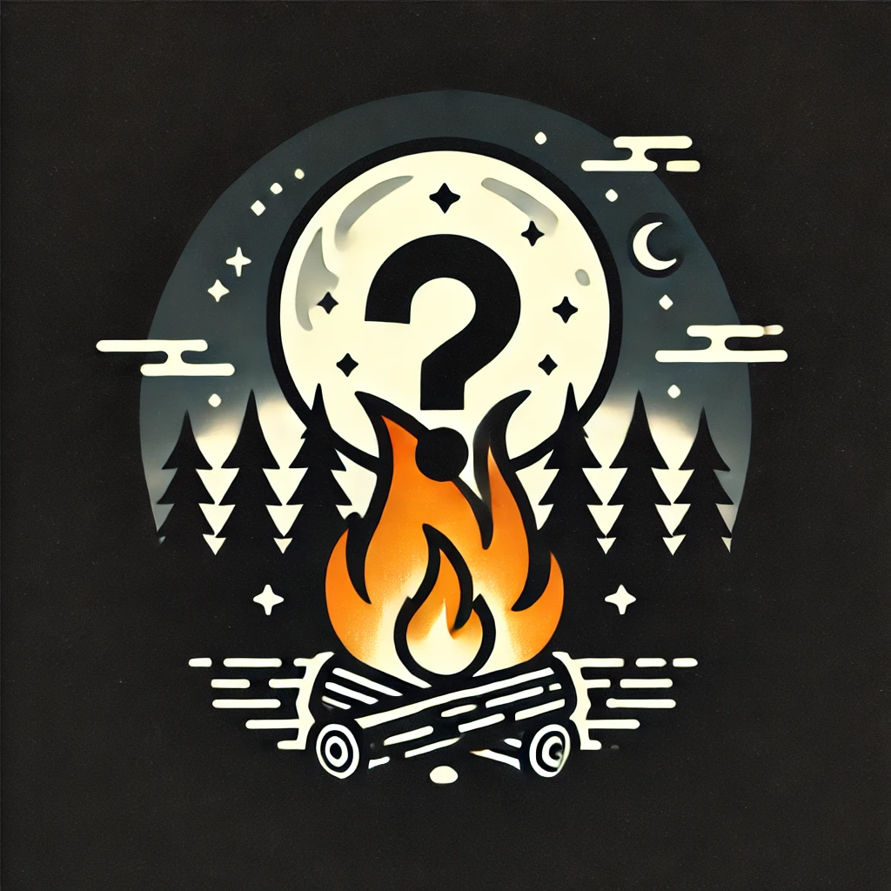

| Bedroll -Tent   * Ground sheet * Foam or self-inflating camp mattress   Bedroll - Tent and Cabin   * Sleeping bag * Extra blanket * Pyjamas * Stuffed animal * Pillow | Mess Kit (not all items are required)   * Mesh bag with string * Plate * Bowl * Cup * Mug (hot drinks) with handle * Knife Spoon Fork * Tea towel |
| --- | --- |
| [Personal Pail Ice cream pail, or other plastic bucket with lid](https://experience.girlguides.ca/node/34696)   * Face washcloth * Soap or other to wash face * Toothbrush * Toothpaste * Cup * Hairbrush * Hair ties /headbands * Chapstick * Menstrual products | Clothing – ONE bag   * 2 pants * 1 Capri or shorts * 2 shirts + 1 long sleeved shirt * 1 Guiding shirt (for Sunday) * Outside shoes (no flip flops) * (at least) 3 pairs of socks * 2 underwear * Hoodie * Rain jacket/poncho * Rain boots/spare shoes   Leggings may be brought as layers for under clothing |
| Day Pack with   * Camp hat * Flashlight (no pen lights/cellphone) * Water bottle (filled with water from home) * Sunscreen * Bug spray * Books or quiet time activity * Pencils/pens/ colouring supplies * Individual first aid kit * Medications – bring in meds bag * SWAPS | Do Not Bring   * Blow up mattress * Scented lotions * Makeup * Jewellery |